Computer Science - C++

LESSON 11: switch statements

OBJECTIVES: The student will write a block of code using a switch statement.

ACTIVITIES/TIME: Three Days
Day one: Presentation - 50 minutes
Days two-three: Lab Exercise - 50 minutes

MATERIALS: Student Outline O.A.11.1
Lab Exercise, L.A.11.1, Grades
Answer Sheet, L.A.11.1
Lab Exercise, L.A.11.2, ACSLLand - Intermediate Division
Answer Sheet, L.A.11.2
Lab Exercise, L.A.11.3, ACSLLand - Senior Division
Answer Sheet, L.A.11.3

REFERENCES: Adams, Joel, Sanford Leestma, and Larry Nyhoff. C++ An Introduction to Computing. Chapter 2.

Deitel, Harvey M. and Paul J. Deitel. C++ How to Program. Chapter 2.

Savitch, Walter. Problem Solving with C++. Pages 365-369.

INSTRUCTOR
NOTES: This lesson is a breather for you and the students. The content is short and relatively easy. It gives you time to catch up and take a break from the large doses of syntax.

There are several programming labs available to use in this lesson. The first one, L.A.11.1,Grades, is a lab which focuses on the switch control structure. The other two labs are different versions of the same lab, ACSLLand. While it might be useful to have covered arrays and records to deal with the Senior level lab, we have covered enough of the language for students to solve these problems. If you have the time, assign the appropriate level lab to your students. You might even want to make the different levels available to students of differing abilities and grade them accordingly.

The ACSLLand labs are used by permission of the American Computer Science League (ACSL). This organization exists to promote the instruction of computer science topics at the junior high and high school levels. ACSL runs competitions consisting of four individual contests. Each contest has a 30 minute short problem exam and a 72-hour programming problem. The short problem section is taken at school but the programming problem is distributed to the contestants and solved outside of class. Students have 72 hours to complete a working program which is then tested with selected data provided by ACSL. The programming questions are concise, well-designed, and provide a good summary exercise of a student's knowledge and skills. For your reference, the address, phone number, and electronic address of the American Computer Science League are:

American Computer Science League
P.O. Box 40118
Providence, RI 02940

(401) 822-4312

http://www.acsl.org

You might try the following approach with the ACSL labs. Pass out the assignment and allow the students 72 hours to complete the solution. They can verify their programs using the sample data on page one of the ACSLLand lab exercise, but do not distribute the test data on page two. The students must turn in a compiled version of their program to be graded by the instructor using the test data from page two. Each line of input will be worth 20% of the total assignment.

STUDENT OUTLINE

Lesson 11 - switch Statements

INTRODUCTION: We now conclude our coverage of control structures by learning about the multi-way selection tool, switch. An example application of this selection tool appears as the pull-down menus used in current software. Depending on which command is chosen, the program will select one direction out of many. The switch statement in C++ allows such decision making.

The key topic for this lesson is:

A. The switch Statements

VOCABULARY: switch

DISCUSSION: A. The switch Statements

1. The general form of a switch statement is:

switch (expression)
{
case value1:
statement1;
statement2;
...
break;
case value2:
statement3;
statement4;
...
break;
case valuen:
statement;
statement;
break;
default:
statement;
statement;
} /* end of switch statement */

2. The flow of control of a switch statement is illustrated in this diagram:

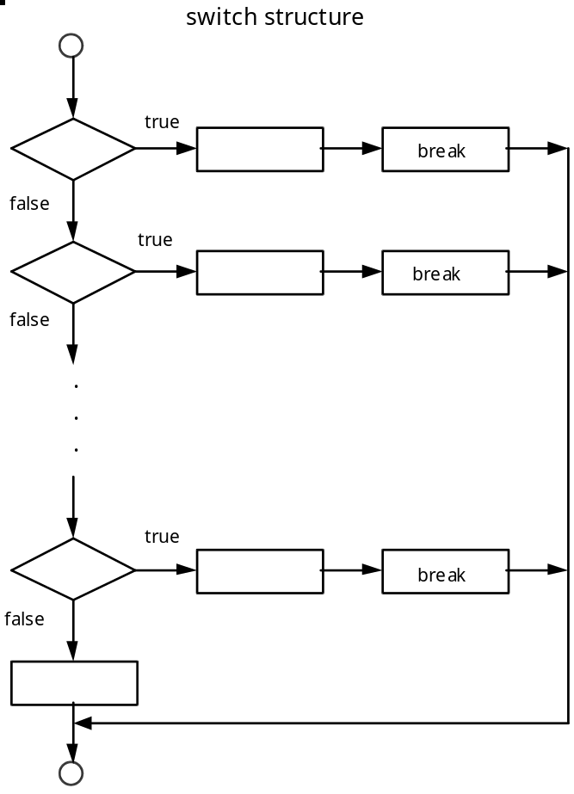

3. The switch statement attempts to match the integer value of the expression with one of the case integer values.

4. If a match occurs, the statements belonging to the case value are executed until the break statement is encountered.

5. The effect of the break statement causes program control to jump to the end of the switch statement. No other cases are executed.

6. A very common error when coding a switch control structure is forgetting to include the break statements to terminate each case value. If the break statement is omitted, all cases following the matching case value are executed. This is usually very undesirable.

7. If no match occurs between the expression and the case values, the optional default choice is executed.

8. The following example applies the switch statement to printing the work day of the week corresponding to a value (1-5):

switch (day)
{
case 1: cout << "Monday" << endl; break;
case 2: cout << "Tuesday" << endl; break;
case 3: cout << "Wednesday" << endl; break;
case 4: cout << "Thursday" << endl; break;
case 5: cout << "Friday" << endl; break;
default: cout << "not a valid day" << endl; break;
}

9. Suppose we wanted to count the occurrences of vowels and consonants in a stream of text. The switch statement is able to analyze character data because such data is converted to integer (ASCII) values for processing.

if (('a' <= letter) && (letter <= 'z'))
switch (letter)
{
case 'a' : case 'e' : case 'i' : case 'o' : case 'u' :
vowel++;
break;
default :
consonant++;
break;
}

a. Note that multiple case values can be lead to one set of statements.
b. It is good programming practice to include a break statement at the end of the switch structure. If you need to go back and add another case statement at the end of the switch structure, a break statement already terminates the previous case statement.

10. There are programming situations where the switch statement should not replace an if-else chain. If the value being compared must fit in a range of values to result in a statement, the if-else statement should be used.

if (score >= 90 && score <= 100) grade = 'A';
else
if (score >= 80 && score < 90) grade = 'B';
else
if (score >= 70 && score < 80) grade = 'C';

etc...

You should not replace the above structure with a switch statement.

11. Finally, the switch statement cannot compare double values.

SUMMARY/REVIEW: The programming assignment, L.A.11.1, ACSLLand, will stretch your ability to use control structures effectively. You might want to review the content of Lessons 6-10 before you tackle this problem. Good decomposition into single-purpose functions will make this problem easier to handle and debug.

ASSIGNMENT: Lab Exercise, L.A.11.1, Grades
Lab Exercise, L.A.11.2, ACSLLand - Intermediate Division
Lab Exercise, L.A.11.3, ACSLLand - Senior Division

